Sources

### 1) ****Enhance Gene Editing****

### Machine Learning techniques are continuing to find their ways into genome sequencing and annotation, and other things. It’s also being used in genome-based diagnostics.

### Gene analysis and editing: Understand genes and their components. Predict the impact of gene edits.

**2)**  [**Medical imaging insights**](https://research.aimultiple.com/looking-for-better-medical-imaging-for-early-diagnostic-and-monitoring-contact-the-leading-vendors-here/)**:**Advanced medical imaging to analyze and transform images and model possible situations.

[**SkinVision:**](https://www.skinvision.com/) SkinVision enables you to find skin cancer early by taking photos of your skin with your phone and getting to a doctor at the right time.

AI-powered medical imaging is also widely used in diagnosing COVID-19 cases and identifying patients who require ventilator support. For example, a Chinese company, [Huiying Medical](https://venturebeat.com/2020/03/27/huiying-medical-claims-its-ai-can-detect-coronavirus-from-ct-scans-with-96-accuracy/" \t "_blank), has developed an AI-powered medical imaging solution with 96% accuracy.

3) **Drug discovery:**Find new drugs based on previous data and medical intelligence.

[**NuMedii**](http://numedii.com/)**:**Biopharma company, NuMedii has built a technology, AIDD (Artificial Intelligence for Drug Discovery) that harnesses Big Data and AI to rapidly discover connections between drugs and diseases at a systems level.

<https://research.aimultiple.com/looking-for-better-medical-imaging-for-early-diagnostic-and-monitoring-contact-the-leading-vendors-here/>

## 4) **Robot moxi**: AA.I. company creating robot assistants that help healthcare workers with routine tasks so they can focus on what they do best.

## Moxi was first brought to Cedars Sinai in September 2021, and in just its first six weeks, it saved 300 miles of walking for nurses. Moxi works all hours of the day.

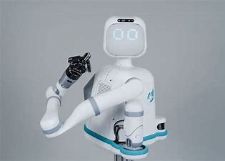

5) **. The *da Vinci*® Surgical Robot**

More than 250,000 people die in the U.S. each year from medical errors, some of which are likely preventable.1 While this is a broad category encompassing a range of different problems, it's certainly true that the more control surgeons have in their operations, the better. The *da Vinci* Surgical System, a multi-armed wonderbot, is being used to reduce surgical errors and make surgery less invasive for thousands of patients.

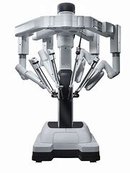

6) **The Xenex Germ-Zapping Robot**

Along with minimizing medical and surgical errors, hospital-acquired infections (HAIs) are another widespread problem in healthcare that could be improved with robots.

the Xenex, an automated and portable robot, is used to disinfect entire hospital rooms in minutes using pulsed, full-spectrum UV rays that kill a range of infectious bacteria. It's designed to reduce HAIs such as Methicillin-resistant Staphylococcus aureus (MRSA) by killing the microorganisms that cause them, which can be particularly resistant to treatment. Plus, the robot is kind of cute—it looks like an R2-D2 designed to save lives.

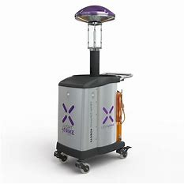

7) **ROBOT:THE TUG**

You may never think about it, but transporting supplies, meals and other materials around the hospital is a drag on efficiency. One estimate shows that a typical 200-bed hospital moves meals, linens, lab samples, waste and other items the equivalent of 53 miles per day.7 Enter TUG, an autonomous mobile robot developed by Aethon Inc. to ferry supplies to where they are needed, freeing employees from heavy physical loads and allowing them to focus on patient care.

When the University of California, San Francisco Medical Center at Mission Bay opened in 2015, it rolled out 25 TUG robots to improve their transportation operations.8 They are programmed with the hospital's floor plan and are also equipped with a variety of sensors to ensure they don't run into anything on their way to the lab. They also kindly ask people to stand aside as they move into congested hallways.

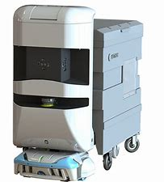

## <https://online-engineering.case.edu/blog/medical-robots-making-a-difference>